Bromley Team Trials date

Sunday 2 March 2008

Please Print Clearly:

Full Name:__________________________________________
Address:_______________________________________________________
Post Code:________________________________
Telephone Number: _______________________________
Date of Birth________________________________
Age on 13/04/08________________________________
School or Club:___________________________________________

Declaration:I agree to my (please delete as appropriate) daughter / son (who is a resident or receives full time education within the London Borough of Bromley) participating in this event and, if selected, in ‘The Adidas Mini London Marathon’. I hereby declare that they are in good health; further, I acknowledge that the copyright of any photography taken during the event belongs to the photographer and that Bromley Mytime may use such photographs in any publication / promotion, including electronic media.

Signature of Parent / Guardian:____________________________

Closing date for entries is Friday 22 February 2008

ENTRY IS FREENO LATE ENTRIES

Completed forms MUST be returned to: David Liston,
70 Sermon Drive,
Swanley, Kent.
BR8 7HT
Telephone Number: 01322 663504
The London Borough of Bromley Trials

Sunday 2nd March 2008
The trials are open to both girls and boys aged between 11 & 17 years, who either live, or receive full time education within the
London Borough of Bromley.

Schedule for the trials:
TIME:CATEGORY:DISTANCE:
10.15amBoys:11 & 125km
10.45amGirls:11 & 125km
11.30amGirls & Boys13 & 145km
12.00 noonGirls & Boys15, 16 & 175km

Bromley aims to select the strongest possible team to continue it’s previous successes. If you are a recognised strong athlete but
unable to attend the trials, you MUST advise the organiser and supply a current history to help the selection process. However, the trials will allow automatic selection to a minimum of 4 runners, one of which will be a “wild card” selected on the day.

Each trial will start and finish on the running track at Norman Park: the course will consist of a double circuit of the perimeter pathways of the park. Age groups are based on the ages of the competitors on the day of the ‘Adidas Mini London Marathon’, Sunday 13 April 2008. Competitors MUST arrive in good time to collect their
running numbers, which must be attached securely to the front of their running attire. There will be no acknowledgement of entries, but please note that entries will not be accepted without an
authorised signature of a parent / guardian, or if appropriate details are incomplete.

NB if successfully selected for the team you must be available on the actual marathon race date, Sunday 13 April 2008.
Confirmation letters will be sent to all successful athletes.

Full changing, shower and toilet facilities are available at the track.

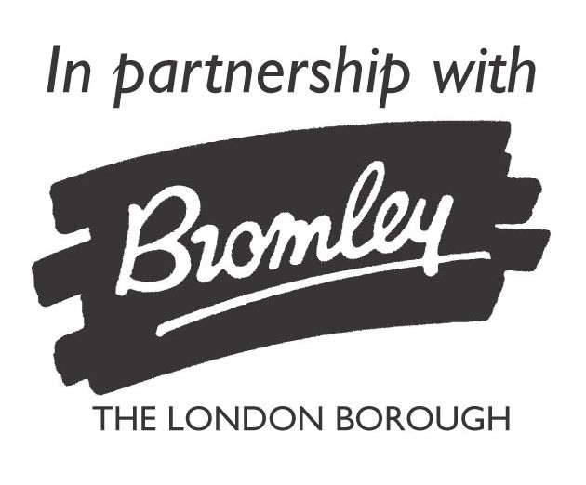

The London Borough of Bromley...
Trials sponsored by

Blackheath & Bromley Harriers Athletics Club

At Norman Park, Bromley
Sunday 2nd March 2008
The Adidas Mini London Marathon
This event as usual, will be run on the morning of the London Marathon, over approximately the last 5km of the course, finishing in The Mall.

Bromley has a remarkable record in the Mini Marathon, usually finishing in the top four.

The current sponsors of the Mini Marathon, ‘Adidas’ are keen to ensure that the event retains it’s charitable reputation; this year we, in Bromley, are encouraging participants to obtain
sponsorship money to help with the provision of good competitive opportunities for Bromley’s young disabled athletes.

As in previous years the London Boroughs and additional
selected guest counties throughout the United Kingdom will be participating.

Teams will consist of 8 runners, girls and boys, in three age groups with only the London Borough teams scoring in the overall competition.
Marathon race date - Sunday 13 April 2008
Blackheath & Bromley Harriers Athletics Club

